What do you think
- Write down what you think the difference is between soil and dirt
- List as many reasons you can think of why soil is a precious resource
SOIL
- Geologic definition:
- Traditional definition:
Dirt
- Soil out of place and unable to serve its purpose
Functions of Soil
1.
2.
3.
4. Engineering Medium-Soil effects the types of Building construction activities.
- Soil supporting life
- How do the following depend on and use soil?
1.
2.
3.
Importance of Soil
- Foundation for
- Home
- Grow
- Contains
- Helps
- Basis

Soils Perform Several Vital Functions
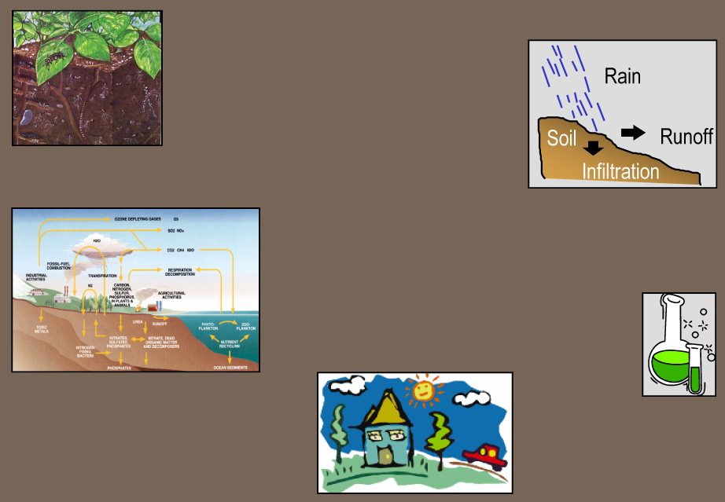

Using a computer look up the following information
- What is arable soil?
- How much land in being actually arable land in the U.S.?
- How much land is arable in the world?
- Explain what you think can be done to help conserve the soil in the U. S. and in the world.
- How is the growing population effecting this?

